Single-homed AS

🌐 What Is Single-homed AS?
# Source: AI Source: Provided by: [Data Path: Persons Table -> ID Column: 1, Name_En Column: Motasem Essam] -> From: [ChatGPT] on [1/16/2026]
A Single-Homed AS (Autonomous System) is a network that is connected to only one upstream Internet Service Provider (ISP). It uses BGP (Border Gateway Protocol) to exchange routing information — but only with one provider.

🧠 Simple Definition:
# Source: AI Source: Provided by: [Data Path: Persons Table -> ID Column: 1, Name_En Column: Motasem Essam] -> From: [ChatGPT] on [1/16/2026]
A Single-Homed AS connects to one ISP using BGP for internet access, but does not have redundancy.

📦 Key Characteristics
# Source: AI Source: Provided by: [Data Path: Persons Table -> ID Column: 1, Name_En Column: Motasem Essam] -> From: [ChatGPT] on [1/16/2026]
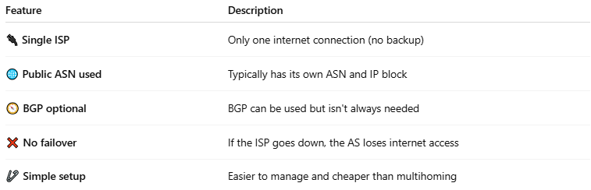

Feature | Description
🔌 Single ISP | Only one internet connection (no backup)
🌐 Public ASN used | Typically has its own ASN and IP block
🧭 BGP optional | BGP can be used but isn't always needed
❌ No failover | If the ISP goes down, the AS loses internet access
🧷 Simple setup | Easier to manage and cheaper than multihoming

🖼️ Visual Example
# Source: AI Source: Provided by: [Data Path: Persons Table -> ID Column: 1, Name_En Column: Motasem Essam] -> From: [ChatGPT] on [1/16/2026]
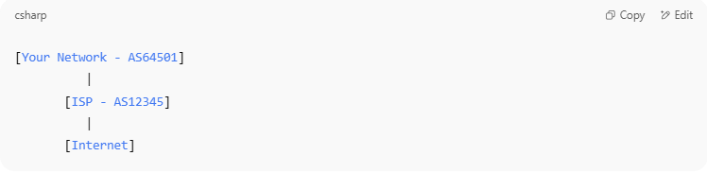

[Your Network - AS64501]
|
[ISP - AS12345]
|
[Internet]

🧱 When Is It Used?
# Source: AI Source: Provided by: [Data Path: Persons Table -> ID Column: 1, Name_En Column: Motasem Essam] -> From: [ChatGPT] on [1/16/2026]
- Small to medium enterprises
- Educational institutions
- Organizations with limited routing needs
- Networks that don’t require high availability

✅ Pros and ❌ Cons
# Source: AI Source: Provided by: [Data Path: Persons Table -> ID Column: 1, Name_En Column: Motasem Essam] -> From: [ChatGPT] on [1/16/2026]
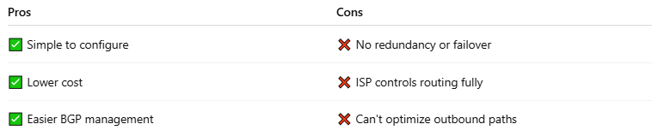

Pros | Cons
✅ Simple to configure | ❌ No redundancy or failover
✅ Lower cost | ❌ ISP controls routing fully
✅ Easier BGP management | ❌ Can't optimize outbound paths

🔁 Comparison Table
# Source: AI Source: Provided by: [Data Path: Persons Table -> ID Column: 1, Name_En Column: Motasem Essam] -> From: [ChatGPT] on [1/16/2026]
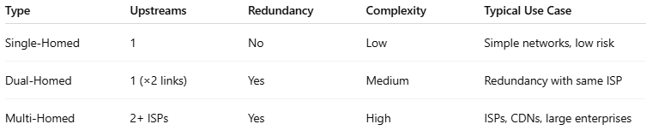

Type | Upstreams | Redundancy | Complexity | Typical Use Case
Single-Homed | 1 | No | Low | Simple networks, low risk
Dual-Homed | 1 (×2 links) | Yes | Medium | Redundancy with same ISP
Multi-Homed | 2+ ISPs | Yes | High | ISPs, CDNs, large enterprises

✅ Summary
# Source: AI Source: Provided by: [Data Path: Persons Table -> ID Column: 1, Name_En Column: Motasem Essam] -> From: [ChatGPT] on [1/16/2026]
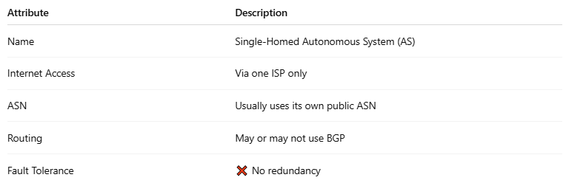

Attribute | Description
Name | Single-Homed Autonomous System (AS)
Internet Access | Via one ISP only
ASN | Usually uses its own public ASN
Routing | May or may not use BGP
Fault Tolerance | ❌ No redundancy

